SOUTHEASTERN CHRISTIAN ACADEMY

COURSE SYLLABUS

ENGL 420 – WORLD LITERATURE

GENERAL INFORMACION


Website: http://www.southeasternchristianacademy.org

E-mail: info@southeasternchristianacademy.org
Grade Level: 10Th

Grade Course: ENGL 410 – WORLD LITERATURE

COURSE DESCRIPTION

This course is structured to enable students to develop knowledge of world through integrated educational experience in the language art. Emphasis will be on representative literature of various cultures and world literary movements from ancient times to the present, including fiction, nonfiction, poetry, and drama chosen on the basis of relationships to contemporary cultural, social, and literary ideas and corncerns.

COURSE OBJETIVES

Student will:
- Understanding of literary terms and their significance.
- Understanding of how history and culture inform literature.
- Analyze short stories novels, plays, poetry, and essays.
- Develop strategies for thinking and writing critically, and independently, about literature.
- Develop and refine writing skills.

TECHNICAL REQUIMENTS/SKILLS

One of the greatest barriers to taking an online course is a lack of basic computer literacy. By computer literacy we mean being able to manage and organize computer files efficiently, and learning to use your computer’s operating system and software quickly and easily. Keep in mind that this is not computer literacy course; but students enrolled in online courses are expected to have moderate proficiency using computer.

TEXTBOOK
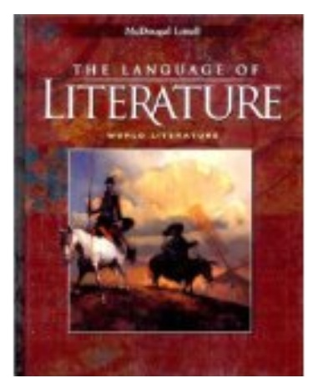
Title: McDougal Little Language of Literature
Author: McDougal Littel
Edition: 2001

INSTRUCTIONAL MATERIALS AND REFERENCES

- Book Reference:

  - McDougal Littell Language of Literature: The Interactive Reader Plus with Audio CD-Rom World Literature.
  - The Bedford Introduction to Literature, High School version – Michael meyer.

- Web Reference:
- http://eliterature.org
- http://www.contemporaryworldliterature.com
- http://online-literature.com
- http://americanliterature.com
- http://loa.org American Literature – Library of America – Fiction, History, and Poetry.

GRADING & EVALUATION POLICY

COURSE REQUIMENTS | WEIGHT
Quizzes | 40%
Student Home Page | 2%
Discussion/Participation | 10%
Assignments | 15%
Exam (Online) | 1%
Final Exam (Online) | 2%
Research Paper | 18%
TOTAL 100%

A | 100-90
B | 89-80
C | 79-70
D | 69-60
F | 59 & below

Topical Outline:

Unit 1
Part 1: Ancient Middle East
Part 2: Ancient India

Unit 2
Part 1: Ancient Greece
Part 2: Ancient Rome

Unit 3
Part 1: Ancient China
Part 2: Japan

Unit 4
Part 1: Persia and Arabia
Part 2: West Africa

Unit 5
Part 1: Middle Ages
Part 2: Renaissance and Enlightenment

Unit 6:
Part 1: Romanticism
Part 2: Realism

Unit 7
Part 1: Modernism
Part 2: War and Conflict
Part 3: Nobel Prize Winners

ACADEMIC MISCONDUCT:

Academic misconduct includes cheating (using unauthorized materials, information, or study aids in any academic exercise), plagiarism, falsification of records, unauthorized possession of examinations, intimidation, and any and al other actions that may improperly affect the evaluation of a student’s academic performance or achievement, or assisting others in any such act or attempts to engage in such acts. Academic misconduct in any form is inimical to the purposes and functions of the school and therefore is unacceptable and prohibited.
Any faculty member, administrator or staff members may identify an act of academic misconduct and should report that act to the department head or administrative supervisor.
Students violating the standards of academic honesty are subject to disciplinary action including reduction of a grade(s) in a specific course, assignment, paper, or project; a formal or informal reprimand at the professorial, dean, or academic vice president level; expulsion from the class in which the violation occurred; expulsion from a program; or expulsion from the school.

