SOUTHEASTERN CHRISTIAN ACADEMY

COURSE SYLLABUS

SPAN801 – FOREIGN LANGUAGE (SPANISH)

GENERAL INFORMACION


Website: http://www.southeasternchristianacademy.org

E-mail: info@southeasternchristianacademy.org
Grade Level: 12Th

Grade Course: SPAN801 – FOREING LANGUAGE (SPANISH)

COURSE DESCRIPTION

This course is an introduction to the Spanish Language. Students perform the most basic of functions of the language and become familiar with some of the elements of its culture. The emphasis is based on the development of listening, speaking, reading, and writing skills that promote meaningful language practice.

COURSE OBJETIVES

- Students will be able to talk about common phrases and expressions on the topics of greeting, describing people, likes and dislikes, weather conditions, the day of the week, months, seasons, and be able to tell time.
- Students will be able to understand all forms of greetings in Spanish, useful phrases and will be able to use them.
- Count 1- 1,000.000, Know the colors, Understand concepts of gender in Spanish grammar, masculine and feminine.
- Students will be able to map the Spanish-speaking countries and know their names and capitals.

TECHNICAL REQUIMENTS/SKILLS

One of the greatest barriers to taking an online course is a lack of basic computer literacy. By computer literacy we mean being able to manage and organize computer files efficiently, and learning to use your computer’s operating system and software quickly and easily. Keep in mind that this is not computer literacy course; but students enrolled in online courses are expected to have moderate proficiency using computer.

TEXTBOOK
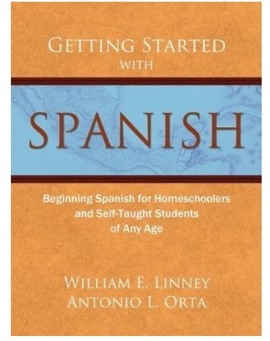
Title: Getting Started with Spanish
Author: William E. Linney
Publisher: Armfield Academic Press - 2009
ISBN: B00N4FP68E
Subject: Spanish – Foreign Language

INSTRUCTIONAL MATERIALS AND REFERENCES

Online Writing References:
- www.elibrary.com
- www.classzone.com
- www.gettingstartedwithspanish.com
- www.classicspanishbook.com
- www.britanica.com/spanish

GRADING & EVALUATION POLICY

COURSE REQUIMENTS | WEIGHT
Quizzes | 40%
Student Home Page | 2%
Discussion/Participation | 10%
Assignments | 15%
Exam (Online) | 1%
Final Exam (Online) | 2%
Research Paper | 18%
TOTAL 100%

A | 100-90
B | 89-80
C | 79-70
D | 69-60
F | 59 & below

Topical Outline
Unit 1- Introduction to the Spanish –speaking world.
Greet people at different times of the day.
Introduce yourself to others.
Begin using numbers.
Begin to tell time.
Identify parts of the body.
Talk questions about new words and phrases.
Use the Spanish alphabet.
Talk about things related to the calendar.
Describe weather conditions.
Identify the seasons.
Compare weather in the northern and southern hemispheres.

Unit 2 – Grammar
Infinitives
Negatives
Expressing agreement or disagreement
Adjectives
Definite and indefinite articles
The plural of adjectives
The verb ser (to be)

Unit 3 – Cultural Topics
Continents and countries where Spanish is spoken.

ACADEMIC MISCONDUCT:

Academic misconduct includes cheating (using unauthorized materials, information, or study aids in any academic exercise), plagiarism, falsification of records, unauthorized possession of examinations, intimidation, and any and al other actions that may improperly affect the evaluation of a student’s academic performance or achievement, or assisting others in any such act or attempts to engage in such acts. Academic misconduct in any form is inimical to the purposes and functions of the school and therefore is unacceptable and prohibited.
Any faculty member, administrator or staff members may identify an act of academic misconduct and should report that act to the department head or administrative supervisor.
Students violating the standards of academic honesty are subject to disciplinary action including reduction of a grade(s) in a specific course, assignment, paper, or project; a formal or informal reprimand at the professorial, dean, or academic vice president level; expulsion from the class in which the violation occurred; expulsion from a program; or expulsion from the school.

