SOUTHEASTERN CHRISTIAN ACADEMY

COURSE SYLLABUS

RELG 600 – RELIGION

GENERAL INFORMACION


Website: http://www.southeasternchristianacademy.org

E-mail: info@southeasternchristianacademy.org
Grade Level: 10Th

Grade Course: RELG 600 - RELIGION

COURSE DESCRIPTION

The purpose of this course will get a sweeping view of the books of the Bible while they discover stories and key figures that left a mark on Christian for eternity.

COURSE OBJETIVES

- Identify the key people, places, and events of the Old Testament.
- Provide the setting and purpose for each Old Testament book.
- Identify the different eras in the history of Israel.
- Identify the various prophets with the era in which they ministered.

TECHNICAL REQUIMENTS/SKILLS

One of the greatest barriers to taking an online course is a lack of basic computer literacy. By computer literacy we mean being able to manage and organize computer files efficiently, and learning to use your computer’s operating system and software quickly and easily. Keep in mind that this is not computer literacy course; but students enrolled in online courses are expected to have moderate proficiency using computer.

TEXTBOOK
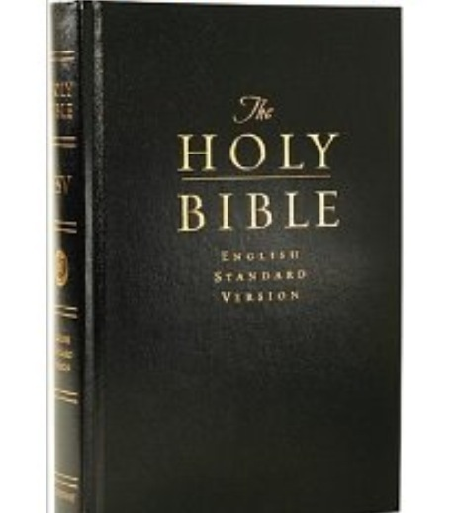
Title: Bible – Christian Bible
Author(s): King James
Publisher: kindle Edition

INSTRUCTIONAL MATERIALS AND REFERENCES

I. Book Reference:
- The Bible As It Was by James L. Kugel
- How to Read the Bible: A Guide to Scripture, Then and Now by James L. Kugel
- Getting Involved with God: Rediscovering the Old Testament by Ellen Davis.

II. Web Reference:
- http://www.biblesstudytools.com
- http://www.biblehub.com - Encyclopedia
- http://www.classzone.com
- http://bible.com - The Bible App
- http://wwwopenlibrary.com

GRADING & EVALUATION POLICY

COURSE REQUIMENTS | WEIGHT
Quizzes | 40%
Student Home Page | 2%
Discussion/Participation | 10%
Assignments | 15%
Exam (Online) | 1%
Final Exam (Online) | 2%
Research Paper | 18%
TOTAL 100%

A | 100-90
B | 89-80
C | 79-70
D | 69-60
F | 59 & below

TOPICAL OUTLINE

UNIT 1: CREATION
  - Overview of the Bible
  - Creation
  - Fall
  - Temptation
  - Promises of God
  - Cain and Abel
  - Flood
  - Nation
  - Creation to Abraham

UNIT 2: ABRAHAM THROUGHT JOSEPH
  - Abraham
  - Call From God
  - Egypt to Covenant
  - Isaac
  - Jacob
  - Rebekah
  - Abraham through Joseph

UNIT 3: THE EXODUS AND WANDERINGS
  - Exodus
  - Leviticus
  - Deuteronomy

UNIT 4: ISRAEL IN CANAAN

UNIT 5: THE JUDGES AND SPIRITUAL DECLINE
  - The Book of Judges
  - The Story of Ruth

UNIT 6: THE KINGDOM
  - The Ministry of Samuel
  - The selection of a King
  - The Reign of Saul
  - The Demise of Saul
  - The Reign of David
  - The King of Solomon
  - Job
  - Psalms
  - Proverbs
  - Ecclesiastes

UNT 7: THE DIVIDED AND REMAINING KINGDOM

UNIT 8: THE CAPTIVITY
  - Jeremiah, Ezequiel, Daniel.

UNIT 9: THE RESTORATION
  - First Return to Exile
  - The Preservation in Exile
  - The Reform in Jerusalem
  - Rebuilding the Walls of Jerusalem

ACADEMIC MISCONDUCT:

Academic misconduct includes cheating (using unauthorized materials, information, or study aids in any academic exercise), plagiarism, falsification of records, unauthorized possession of examinations, intimidation, and any and al other actions that may improperly affect the evaluation of a student’s academic performance or achievement, or assisting others in any such act or attempts to engage in such acts. Academic misconduct in any form is inimical to the purposes and functions of the school and therefore is unacceptable and prohibited.
Any faculty member, administrator or staff members may identify an act of academic misconduct and should report that act to the department head or administrative supervisor.
Students violating the standards of academic honesty are subject to disciplinary action including reduction of a grade(s) in a specific course, assignment, paper, or project; a formal or informal reprimand at the professorial, dean, or academic vice president level; expulsion from the class in which the violation occurred; expulsion from a program; or expulsion from the school.

