SOUTHEASTERN CHRISTIAN ACADEMY

COURSE SYLLABUS

GEOMETRY 130 – MATHEMATICS

GENERAL INFORMACION


Website: http://www.southeasternchristianacademy.org

E-mail: info@southeasternchristianacademy.org
Grade Level: 11Th

Grade Course: Geometry 130 – Mathematics

COURSE DESCRIPTION

This eleventh grade mathematics course is a complete course is Geometry. The course covers formal proofs, deductive and inductive reasoning, indirect proofs, and plane geometry, coordinate geometry and trigonometry. The course is structured to teach the theory of geometry and its applications. Therefore, students will learn geometric theorems and their applications.

COURSE OBJETIVES

- Apply and demonstrate the different way numbers are represented and used in the real world.
- Determine the effects of operations on numbers and relationship among these operations.
- Select appropriate operations, and compute for problem solving.
- Write and solve and multi-step equations including real-world applications.

TECHNICAL REQUIMENTS/SKILLS

One of the greatest barriers to taking an online course is a lack of basic computer literacy. By computer literacy we mean being able to manage and organize computer files efficiently, and learning to use your computer’s operating system and software quickly and easily. Keep in mind that this is not computer literacy course; but students enrolled in online courses are expected to have moderate proficiency using computer.

TEXTBOOK
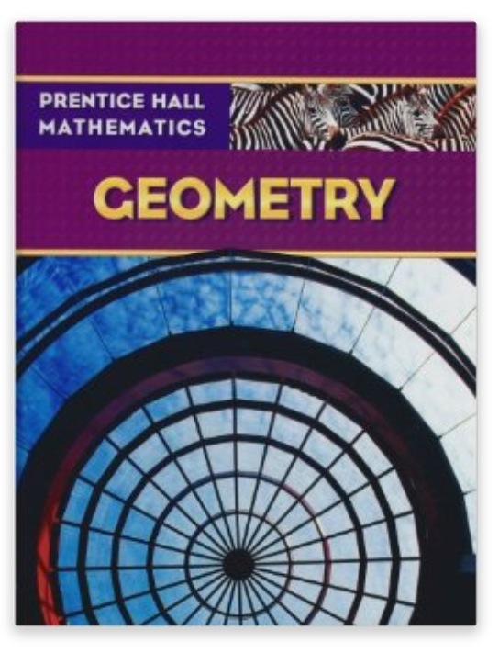
Title: Prentice Hall Math: Geometry, Students Edition
Author: Laurie E. Bass
Edition: 1st edition
ISBN: 13-978-01311339972 - ISBN-10:0131339974
Subject: Geometry

INSTRUCTIONAL MATERIALS AND REFERENCES

I. Book Reference:

- Geometry: A Comprehensive Courses (Dover Books on Mathematics)
- Geometry: Mcdougal Littell High School Math. Edition by Ron Larson, Laurie Boswell, Lee Stiff.
- Geometry: Concepts & Skills, Student Edition.
- Pentice Hall Math: Geometry, Students Edition by Laurie E. Bass / An online copy is also available.

II. Web Reference:

- http://www.coursesmart.com
- http://www.mathreference.com
- http://www.classzone.com
- http://www.math.com
- http://wwwopenlibrary.com
- http://www.sosmath.com
- http://www.algebra.com

GRADING & EVALUATION POLICY

COURSE REQUIMENTS | WEIGHT
Quizzes | 40%
Student Home Page | 2%
Discussion/Participation | 10%
Assignments | 15%
Exam (Online) | 1%
Final Exam (Online) | 2%
Research Paper | 18%
TOTAL 100%

A | 100-90
B | 89-80
C | 79-70
D | 69-60
F | 59 & below

Topical Outline

Chapter 1 | Tools of Geometry
Chapter 2 | Reasoning and Proof
Chapter 3 | Parallel and Perpendicular Lines
Chapter 4 | Congruent Triangles
Chapter 5 | Relationships within Triangles
Chapter 6 | Quadrilaterals
Chapter 7 | Similarity
Chapter 8 | Right Triangles and Trigonometry
Chapter 9 | Transformations
Chapter 10 | Area
Chapter 11 | Surface Area and volume
Chapter 12 | Circles
Chapter 13 | Combinatory and Probability
Chapter 14 | Statistics and Data Analysis
Chapter 15 | Introduction to Calculus

ACADEMIC MISCONDUCT:

Academic misconduct includes cheating (using unauthorized materials, information, or study aids in any academic exercise), plagiarism, falsification of records, unauthorized possession of examinations, intimidation, and any and al other actions that may improperly affect the evaluation of a student’s academic performance or achievement, or assisting others in any such act or attempts to engage in such acts. Academic misconduct in any form is inimical to the purposes and functions of the school and therefore is unacceptable and prohibited.
Any faculty member, administrator or staff members may identify an act of academic misconduct and should report that act to the department head or administrative supervisor.
Students violating the standards of academic honesty are subject to disciplinary action including reduction of a grade(s) in a specific course, assignment, paper, or project; a formal or informal reprimand at the professorial, dean, or academic vice president level; expulsion from the class in which the violation occurred; expulsion from a program; or expulsion from the school.

