SOUTHEASTERN CHRISTIAN ACADEMY

COURSE SYLLABUS

ENGL 440 – ENGLISH

GENERAL INFORMACION


Website: http://www.southeasternchristianacademy.org

E-mail: info@southeasternchristianacademy.org
Grade Level: 12Th

Grade Course: ENGL 440 – ENGLISH BRITISH LITERATURE

COURSE DESCRIPTION

During the course, the students will focus on vocabulary, writing, and various genres of literature, including drama, short stories, poetry, and novels. The Common Core State Performance Standards will guide all instruction. Students will focus on reading literary and information texts and writing argumentative, informational, and narrative essays.

COURSE OBJETIVES

Student will be expected to engage with the texts through discussion, writing, and projects. In addition to reading and writing, grammar and mechanics will also covered.

TECHNICAL REQUIMENTS/SKILLS

One of the greatest barriers to taking an online course is a lack of basic computer literacy. By computer literacy we mean being able to manage and organize computer files efficiently, and learning to use your computer’s operating system and software quickly and easily. Keep in mind that this is not computer literacy course; but students enrolled in online courses are expected to have moderate proficiency using computer.

TEXTBOOK

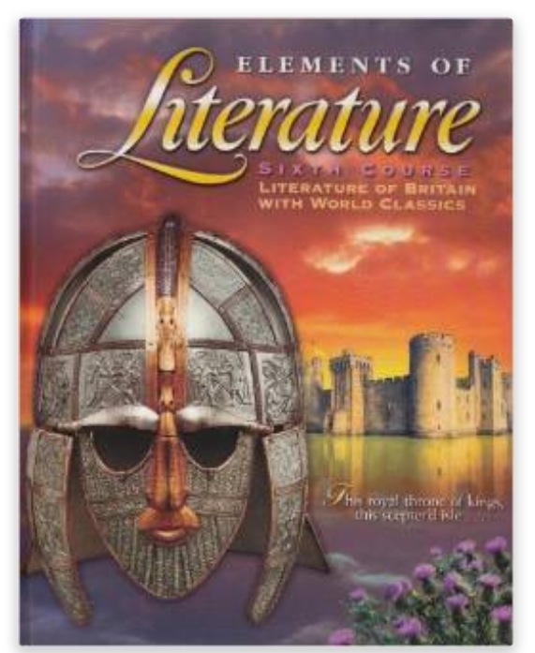
Title: Literature of Britain with World Classic – Sixth Course
Author: Rinehart and Winston Holt
Edition: 1st Edition
ISBN: 13: 978-00300520679 ISBN –10: 0030520673
Subject: English – British Literature

INSTRUCTIONAL MATERIALS AND REFERENCES

I. Online Writing References:
- www.elibrary.com
- www.library.illinois.edu
- www.classzone.com/books - British Literature
- www.archive.org - The Language of Literature; British Literature.

II. Online Literature Guide:
- www.literature.org
- www.oxfordreference.com
- www.onlineliteraturebritishguide.com

GRADING & EVALUATION POLICY

COURSE REQUIMENTS | WEIGHT
Quizzes | 40%
Student Home Page | 2%
Discussion/Participation | 10%
Assignments | 15%
Exam (Online) | 1%
Final Exam (Online) | 2%
Research Paper | 18%
TOTAL 100%

A | 100-90
B | 89-80
C | 79-70
D | 69-60
F | 59 & below

Topical Outline

Unit 1: The Anglo-Saxon Period and Middle Ages 449-1485
. The Anglo-Saxons: Songs of Ancient Heroes
. The Middle Ages: The Tales They Told

Unit 2: The Renaissance 1485-1660 A Flourish of Genius
. Love, Time, and Death
. William Shakespeare

Unit 3: The Restoration and the Eighteenth Century 1660-1800
. The Rise of the Novel
. Examined Lives

Unit 4: The Romantic Period 1798-1832
. Truth and Imagination
. The Quest of Beauty

Unit 5: The Victorian Period 1832-1901
. Love and Loss
. The Paradox of Progress

Unit 6: The Modern World 1900 to the Present
. The World at War
. Modern and Contemporary Poetry
. Expectation and Reality

ACADEMIC MISCONDUCT:

Academic misconduct includes cheating (using unauthorized materials, information, or study aids in any academic exercise), plagiarism, falsification of records, unauthorized possession of examinations, intimidation, and any and al other actions that may improperly affect the evaluation of a student’s academic performance or achievement, or assisting others in any such act or attempts to engage in such acts. Academic misconduct in any form is inimical to the purposes and functions of the school and therefore is unacceptable and prohibited.
Any faculty member, administrator or staff members may identify an act of academic misconduct and should report that act to the department head or administrative supervisor.
Students violating the standards of academic honesty are subject to disciplinary action including reduction of a grade(s) in a specific course, assignment, paper, or project; a formal or informal reprimand at the professorial, dean, or academic vice president level; expulsion from the class in which the violation occurred; expulsion from a program; or expulsion from the school.

