SOUTHEASTERN CHRISTIAN ACADEMY

COURSE SYLLABUS

ENGL 430 – ENGLISH

GENERAL INFORMACION


Website: http://www.southeasternchristianacademy.org

E-mail: info@southeasternchristianacademy.org
Grade Level: 11Th

Grade Course: ENGL 430 – ENGLISH WRITING AND GRAMMAR

COURSE DESCRIPTION

This course is structured to provide students with formal instruction in grammar, literary analysis, vocabulary studies, and writing. Students become familiar with a wide range of literary forms, themes, cultures, and periods, with a concentration on poetry and drama. We analyze various works of literature through discussion and in written compositions.

COURSE OBJETIVES

Student will:

- Analyze the authors use rhetorical of an authors work though structure, repetition of ideas, syntax, and word choice.
- Be able to verify/clarify facts in various texts using different types of workplace documents.
- Analyze and understand how the theme of a short story or novel represents a view or comment on life, using support from the text.
- Analyze various works of American literature representing a variety of genres, time periods, and social views.

TECHNICAL REQUIMENTS/SKILLS

One of the greatest barriers to taking an online course is a lack of basic computer literacy. By computer literacy we mean being able to manage and organize computer files efficiently, and learning to use your computer’s operating system and software quickly and easily. Keep in mind that this is not computer literacy course; but students enrolled in online courses are expected to have moderate proficiency using computer.

TEXTBOOK
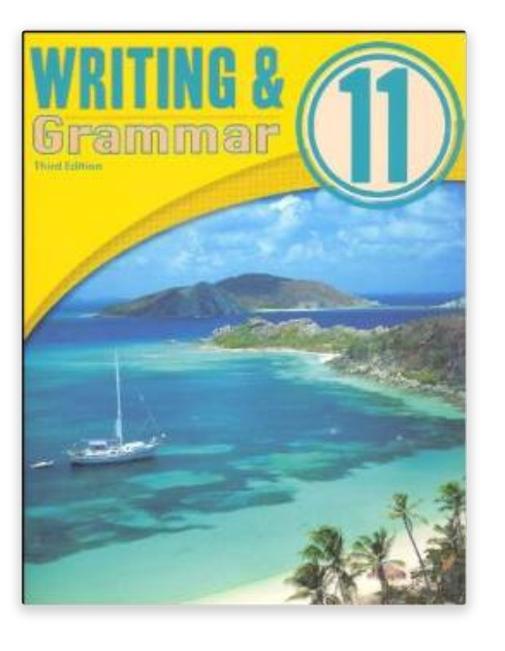
Title: Writing and Grammar 11
Author: Dana Gibby Gage
Edition: 3rd Edition
ISBN: 13: 978-1606820933 ISBN –10: 1606820931
Subject: English – Writing and Grammar

INSTRUCTIONAL MATERIALS AND REFERENCES

I. Online Writing References:
- Webster’s Dictionary & Thesaurus www.webster.com
- Columbia Encyclopedia www.infoplease.com

II. Online Grammar Guide:
- Blue Book of Grammar & Punctuation www.grammarbook.com
- Using English Student References www.usingenglish.com
- Eleven Rules of Writing www.junketstudies.com

GRADING & EVALUATION POLICY

COURSE REQUIMENTS | WEIGHT
Quizzes | 40%
Student Home Page | 2%
Discussion/Participation | 10%
Assignments | 15%
Exam (Online) | 1%
Final Exam (Online) | 2%
Research Paper | 18%
TOTAL 100%

A | 100-90
B | 89-80
C | 79-70
D | 69-60
F | 59 & below

Topical Outline

Chapter 1: The Writing Process
Chapter 2: Analytical Essays/Parts of Speech
Chapter 3: On Line Essays/Sentences
Chapter 4: Folktale/Phrases
Chapter 5: Letter to The Editor/Clauses
Chapter 6: Research Paper/Agreement
Chapter 7: Memoir/Verb Use
Chapter 8: Parallelism/Pronoun Reference
Chapter 9: Interview/Pronoun Use
Chapter 10: Critical Response to Literature/Adjective and Adverb Use
Chapter 11: Analogy/Capitalization
Chapter 12: Narrative Poem/Punctuation
Chapter 13: Hymn/More Punctuation

ACADEMIC MISCONDUCT:

Academic misconduct includes cheating (using unauthorized materials, information, or study aids in any academic exercise), plagiarism, falsification of records, unauthorized possession of examinations, intimidation, and any and al other actions that may improperly affect the evaluation of a student’s academic performance or achievement, or assisting others in any such act or attempts to engage in such acts. Academic misconduct in any form is inimical to the purposes and functions of the school and therefore is unacceptable and prohibited.
Any faculty member, administrator or staff members may identify an act of academic misconduct and should report that act to the department head or administrative supervisor.
Students violating the standards of academic honesty are subject to disciplinary action including reduction of a grade(s) in a specific course, assignment, paper, or project; a formal or informal reprimand at the professorial, dean, or academic vice president level; expulsion from the class in which the violation occurred; expulsion from a program; or expulsion from the school.

