SOUTHEASTERN CHRISTIAN ACADEMY

COURSE SYLLABUS

SCIE 210 – PHYSICAL SCIENCE

GENERAL INFORMACION


Website: http://www.southeasternchristianacademy.org

E-mail: info@southeasternchristianacademy.org
Grade Level: 9th

Grade Course: SCIE 210 – PHYSICAL SCIENCE

COURSE DESCRIPTION

The purpose of this course is to provide opportunities to investigate the theories and ideas associated with the physical science in a way that is relevant and usable.

COURSE OBJETIVES

After completing this course, the student will have studied & analyze the following topics: Approaches to Science, Matter, Energy, Force & Motion (Dynamics), Waves, & Optics, Electric & Circuit, Everyday Solutions, Nuclear Reaction & Law of Conservation of Energy.

TECHNICAL REQUIMENTS/SKILLS

One of the greatest barriers to taking an online course is a lack of basic computer literacy. By computer literacy we mean being able to manage and organize computer files efficiently, and learning to use your computer’s operating system and software quickly and easily. Keep in mind that this is not computer literacy course; but students enrolled in online courses are expected to have moderate proficiency using computer.

TEXTBOOK
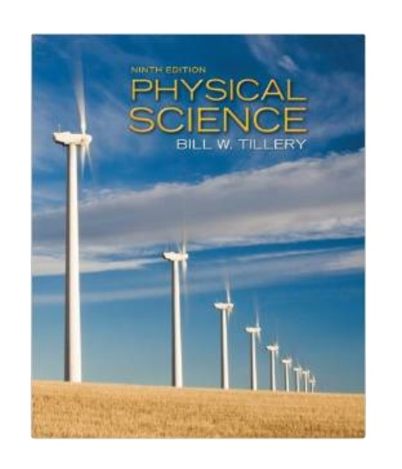
Title: Physical Science
Author(s): Bill Tillery
Publisher: McGraw-Hill Science/Engineering/Math
Edition: 9th
ISBN: 978-0-0735512211 │10: 0073512214

INSTRUCTIONAL MATERIALS AND REFERENCES

I. Book Reference:
- Physical Science / Prentice Hall Science Explorer by David V. Frank and John G, Little.
- Holt Science & Technology / Physical Science by Holt Rinehart Winston.
- Focus on Physical Science by David V. Frank Ph. D

II. Web Reference:
- http://www.loc.gov
- http://www.coursesmart.com
- http://www.lib.ucdavis.edu
- http://www.classzone.com
- http://www.archive.org
- http://wwwopenlibrary.com

GRADING & EVALUATION POLICY

COURSE REQUIMENTS | WEIGHT
Quizzes | 40%
Student Home Page | 2%
Discussion/Participation | 10%
Assignments | 15%
Exam (Online) | 1%
Final Exam (Online) | 2%
Research Paper | 18%
TOTAL 100%

A | 100-90
B | 89-80
C | 79-70
D | 69-60
F | 59 & below

TOPICAL OUTLINE

Chapter 1:The Nature of Science
Chapter 2: Motion and Speed
Chapter 3: Forces
Chapter 4: Energy
Chapter 5: Work and Machines
Chapter 6:Thermal Energy
Chapter 7: Electricity
Chapter 8: Magnetism and Its Users
Chapter 9: Radioactivity and Nuclear Reactions
Chapter 10:Energy Sources
Chapter 11: Waves
Chapter 12: Sound
Chapter 13: Electromagnetic Waves
Chapter 14: Light
Chapter 15: Mirrors and Lenses
Chapter 16: Solids, Liquids, and Gases
Chapter 17: Classification of Matter
Chapter 18: Properties of Atoms and the Periodic Table
Chapter 19: Chemical Bonds
Chapter 20: Elements and Their Properties
Chapter 21: Organic Compounds
Chapter 22: New Materials Through Chemistry
Chapter 23: Solutions
Chapter 24: Chemical Reactions
Chapter 25: Acids, Bases, and Salts

ACADEMIC MISCONDUCT:

Academic misconduct includes cheating (using unauthorized materials, information, or study aids in any academic exercise), plagiarism, falsification of records, unauthorized possession of examinations, intimidation, and any and al other actions that may improperly affect the evaluation of a student’s academic performance or achievement, or assisting others in any such act or attempts to engage in such acts. Academic misconduct in any form is inimical to the purposes and functions of the school and therefore is unacceptable and prohibited.
Any faculty member, administrator or staff members may identify an act of academic misconduct and should report that act to the department head or administrative supervisor.
Students violating the standards of academic honesty are subject to disciplinary action including reduction of a grade(s) in a specific course, assignment, paper, or project; a formal or informal reprimand at the professorial, dean, or academic vice president level; expulsion from the class in which the violation occurred; expulsion from a program; or expulsion from the school.

