SOUTHEASTERN CHRISTIAN ACADEMY

COURSE SYLLABUS

COMPUTER

GENERAL INFORMACION


Website: http://www.southeasternchristianacademy.org

E-mail: info@southeasternchristianacademy.org
Grade Level: 9th

Grade Course: COMPUTER

COURSE DESCRIPTION

In this course students will acquire a working knowledge of Word, Excel, Access and Power Point. Appropriate use of Internet’s resources will be explained along with proper Internet searching skills.

COURSE OBJETIVES

Students will:
- Be able to identify computer hardware and peripheral devices.
- Be familiar with software applications.
- Accomplish creating basic documents, worksheets, presentation and databases.
- Distinguish the advantages and disadvantages of networks.
- Identify computer risk and safety.

TECHNICAL REQUIMENTS/SKILLS

One of the greatest barriers to taking an online course is a lack of basic computer literacy. By computer literacy we mean being able to manage and organize computer files efficiently, and learning to use your computer’s operating system and software quickly and easily. Keep in mind that this is not computer literacy course; but students enrolled in online courses are expected to have moderate proficiency using computer.

TEXTBOOK
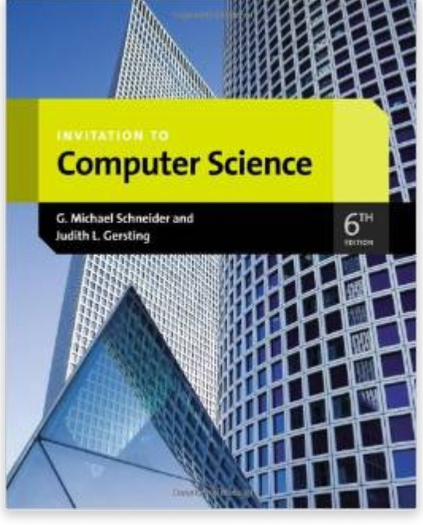
Title: Invitation to Computer Science
Author(s): G. Michael Schneider, Judith Gersting
Publisher: Cengage
Edition: 6th
ISBN: 13: 978-1133190820 │10: 1133190820

INSTRUCTIONAL MATERIALS AND REFERENCES

I. Book Reference:
- Introductions to Computer Science by Gilbert Brands.
- Computer Networks, Fifth Edition: A Systems approach by Larry L. Peterson.
- Connecting with Computer Science (Introduction to Computer Science) by Greg Anderson.

II. Web Reference:
- http://www.wikipedia.org
- http://www.coursera.org
- http://www.classzone.com
- http://www.openlibrary.com

GRADING & EVALUATION POLICY

COURSE REQUIMENTS | WEIGHT
Quizzes | 40%
Student Home Page | 2%
Discussion/Participation | 10%
Assignments | 15%
Exam (Online) | 1%
Final Exam (Online) | 2%
Research Paper | 18%
TOTAL 100%

A | 100-90
B | 89-80
C | 79-70
D | 69-60
F | 59 & below

TOPICAL OUTLINE

- An Introduction to computer Science.
- Computer Systems Organization.
- An Introduction to Systems Software and Virtual Machines.
- Computer Networks, the Internet, and the World Wide Web.
- Information Security
- Making Ethical Decisions.

ACADEMIC MISCONDUCT:

Academic misconduct includes cheating (using unauthorized materials, information, or study aids in any academic exercise), plagiarism, falsification of records, unauthorized possession of examinations, intimidation, and any and al other actions that may improperly affect the evaluation of a student’s academic performance or achievement, or assisting others in any such act or attempts to engage in such acts. Academic misconduct in any form is inimical to the purposes and functions of the school and therefore is unacceptable and prohibited.
Any faculty member, administrator or staff members may identify an act of academic misconduct and should report that act to the department head or administrative supervisor.
Students violating the standards of academic honesty are subject to disciplinary action including reduction of a grade(s) in a specific course, assignment, paper, or project; a formal or informal reprimand at the professorial, dean, or academic vice president level; expulsion from the class in which the violation occurred; expulsion from a program; or expulsion from the school.

