SOUTHEASTERN CHRISTIAN ACADEMY

COURSE SYLLABUS

SCIE 220 – EARTH SCIENCE

GENERAL INFORMACION


Website: http://www.southeasternchristianacademy.org

E-mail: info@southeasternchristianacademy.org
Grade Level: 10th

Grade Course: SCIE 220 – EARTH SCIENCE

COURSE DESCRIPTION

This course is designed to provide students with an overview of the common concepts in earth and space science including but not limited to geology, meteorology, hydrology, and the impact of humans on earth. This course is specifically designed to promote critical thinking skills through the use of the scientific method.

COURSE OBJETIVES

- Describe the scientific method.
- Describe the significance of geology, time, state the age of the earth.
- Discuss global concepts such as locating positions on the earth; e.g. latitude and longitude, the earth’s orbit around the sun, and seasonal variations.
- Describe the composition, structure and circulation of the earth’s atmosphere.
- Describe the universe beyond our solar system and discuss current ides about its age and origin.

TECHNICAL REQUIMENTS/SKILLS

One of the greatest barriers to taking an online course is a lack of basic computer literacy. By computer literacy we mean being able to manage and organize computer files efficiently, and learning to use your computer’s operating system and software quickly and easily. Keep in mind that this is not computer literacy course; but students enrolled in online courses are expected to have moderate proficiency using computer.

TEXTBOOK
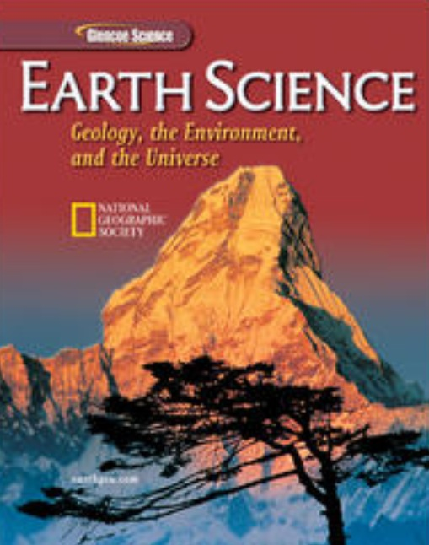
Title: Earth Science: Geology, the Environment, and the Universe.
Author(s): Mc Graw-Hill Education
Publisher: McGraw-Hill Earth Science
Edition:
ISBN: 978-0078664236 │10: 0078664233

INSTRUCTIONAL MATERIALS AND REFERENCES

I. Book Reference:
- Globe Earth Science by Globe Science
- Earth Science by Taruck, Edward J.

II. Web Reference:
- http://www.glencoe.com
- http://www.geology.com
- http://www.coursesmart.com
- http://www.nasa.org
- http://www.classzone.com
- http://wwwopenlibrary.com

GRADING & EVALUATION POLICY

COURSE REQUIMENTS | WEIGHT
Quizzes | 40%
Student Home Page | 2%
Discussion/Participation | 10%
Assignments | 15%
Exam (Online) | 1%
Final Exam (Online) | 2%
Research Paper | 18%
TOTAL 100%

A | 100-90
B | 89-80
C | 79-70
D | 69-60
F | 59 & below

TOPICAL OUTLINE

Chapter 1: The Nature of Science
Chapter 2: Mapping Our World
Chapter 3: Matter and Atomic
Chapter 4: Minerals
Chapter 5: Igneous Rocks
Chapter 6: Sedimentary and Metamorphic Rocks
Chapter 7: Weathering, Erosion, and Soil
Chapter 8: Mass Movements, Wind, and Glaciers
Chapter 9: Surface Water
Chapter 10: Groundwater
Chapter 11: The Atmosphere
Chapter 12: Meteorology
Chapter 13: The Nature of Storms
Chapter 14: Climate
Chapter 15: Physical Oceanography
Chapter 16: The Marine Environment
Chapter 17: Plate Tectonics
Chapter 18: Volcanic Activity
Chapter 19: Earthquakes
Chapter 20: Mountain Building
Chapter 21: Fossil and the Rock Record
Chapter 22: The Precambrian Earth
Chapter 23: The Paleozoic Era
Chapter 24: The Mesozoic and Cenozoic Eras
Chapter 25: Earth Resources
Chapter 26: Energy Resources
Chapter 27: Human Impact on Earth Resources
Chapter 28: The Sun-Earth-Moon System
Chapter 29: Our Solar System
Chapter 30: Stars
Chapter 31: Galaxies and the Universe

ACADEMIC MISCONDUCT:

Academic misconduct includes cheating (using unauthorized materials, information, or study aids in any academic exercise), plagiarism, falsification of records, unauthorized possession of examinations, intimidation, and any and al other actions that may improperly affect the evaluation of a student’s academic performance or achievement, or assisting others in any such act or attempts to engage in such acts. Academic misconduct in any form is inimical to the purposes and functions of the school and therefore is unacceptable and prohibited.
Any faculty member, administrator or staff members may identify an act of academic misconduct and should report that act to the department head or administrative supervisor.
Students violating the standards of academic honesty are subject to disciplinary action including reduction of a grade(s) in a specific course, assignment, paper, or project; a formal or informal reprimand at the professorial, dean, or academic vice president level; expulsion from the class in which the violation occurred; expulsion from a program; or expulsion from the school.

